1. A particle travels 3.5 m. If its initial velocity is 9 m/s and its final velocity is 16 m/s, what is its acceleration?

(A) 1 m/s2

(B) 2 m/s2

(C) 7 m/s2

(D) 25 m/s2

(E) 30 m/s2

2. A projectile launched straight up at 10 m/s will reach a maximum height in:

(A) 1 s

(B) 1.4 s

(C) 2 s

(D) 5 s

(E) 7 s

3. The centripetal force acting on an object is doubled. The radius of the object’s motion is also doubled. The speed of the object:

(A) Increases by a factor of 4.

(B) Increases by a factor of 2.

(C) Decreases by a factor of 2.

(D) The change in the object’s speed depends upon its mass.

(E) Decreases by a factor of 8.

4. A 1 kg mass hangs from a string. The ceiling pulls upward on the same string with a force of 10 N. What is the tension in the string?

(A) 0 N

(B) 10 N

(C) 20 N

(D) 40 N

(E) 80 N

5. A rocket lifting off the Earth's surface develops an upward force of 49831 N accelerates at 38.2 m/s2. What is its mass?

(A) 10000 kg

(B) 5000 kg

(C) 2000 kg

(D) 700 kg

(E) 898 kg

6. A mass on the end of a 0.63 m string moves at 1.94 revolutions per second. What is the magnitude of the centripetal acceleration?

(A) 90 m/s2

(B) 91 m/s2

(C) 92 m/s2

(D) 93 m/s2

(E) 94 m/s2

7. A planet has two moons. The first is 3 times as far from the center of the planet as the second and has a mass that is 3 times the mass of the second. What is the ratio of the gravitational force on the first planet to the gravitational force on the second?

(A) 1

(B) 1.33

(C) 0.33

(D) 2

(E) 1.5

8. A ball on a string swings is a horizontal circle of radius 1.1 m. If its centripetal acceleration is 13.8 m/s2, what is the speed of the ball?

(A) 1.4 m/s

(B) 2 m/s

(C) 4.8 m/s

(D) 2.2 m/s

(E) 3.9 m/s

9. A block is released from rest at a vertical height of 45.4 cm on a plane inclined at an angle of 22.8º from the horizontal and slides down the plane, reaching a speed of 1.66 m/s at the bottom. What is the coefficient of friction between the block and the plane?

(A) 1 s

(B) 0.29 s

(C) 0.5 s

(D) 0.1 s

(E) 0.01 s

10. The block is lowered by a rope as shown. The tension T in the rope is 35 N. If the block is lowered 10 m, how much work is done by the weight of the block?

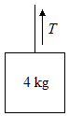

(A) 50 J

(B) 175 J

(C) 350 J

(D) 400 J

(E) 500 J

11. A 2.45 kg bock on a horizontal surface slides into a horizontal spring with a speed of 3.63 m/s. The spring compresses 0.149 m before coming to rest. If the coefficient of friction between the block and the surface is 0.52, what is the force constant of the spring?

(A) 1000 N/m

(B) 4l03 N/m

(C) 1123 N/m

(D) 1.6l04 N/m

(E) 1287 N/m

12. A mass of 10 kg is moved vertically upwards through a distance of 9 m. If the gravitational acceleration is 9.8 m/s2, then the work done against gravity is

(A) 210 J

(B) 420 J

(C) 882 J

(D) 810 J

(E) 568 J

13. If the same force were applied to each of the following, the change in velocity would be the greatest for:

(A) A 5 kg ball moving at 9 m/s

(B) A 7 kg ball moving at 7 m/s

(C) A 10 kg ball moving at 5 m/s

(D) The change in velocity would be the same for all three.

(E) A 10 kg ball moving at 4 m/s

14. The center of each pulley in the pulley system below remains stationary. The pulleys are massless and frictionless. What minimum force F is required to lift the mass?

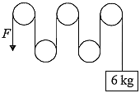

(A) 10 N

(B) 20 N

(C) 30 N

(D) 60 N

(E) 80 N

15. 222*Rn* decays via *α*-particle production to form:

(A) 218*Po*

(B) 220*Th*

(C) 222*At*

(D) 226*Ra*

(E) 223*Ra*

16. A diver swims in a pool that is 30 m deep. The diver swims 20 m above the bottom. What is the gauge pressure?

(A) 105 Pa

(B) 105 atm

(C) 105 torr

(D) 2105 Pa

(E) 5105 Pa

17. An open container of fluid begins draining a spigot at time t = 0. Assume ideal fluid flow. If the container is filled with water, and h is 20 m, the velocity of the water at c is:

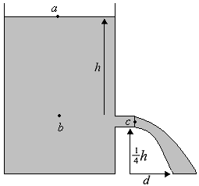

(A) 5 m/s

(B) 10 m/s

(C) 20 m/s

(D) 40 m/s

(E) 50 m/s

18. As a crate slides down from the top of a 2 meter long inclined plane, the coefficient of friction is 0.4. Calculate the work done by friction if the angle of incline is 30° and the mass of the crate is 10 kg.

(A) -68 J

(B) -39 J

(C) -34 J

(D) -20 kJ

(E) -10 kJ

19. A can of paint with a mass of 10 kg hangs from a rope. If the can is to be pulled up to a rooftop with a constant velocity of 0.5 m/s, what must the tension in the rope?

(A) 10 N

(B) 50 N

(C) 75 N

(D) 80 N

(E) 100 N

20. A 30 cm violin string is placed in front of a loud speaker fed by an audio oscillator. What is the lowest frequency at which the audio oscillator can emit sound which will cause the string to vibrate? (Note: Waves propagate along the string at 264 m/s.)

(A) 440 Hz

(B) 880 Hz

(C) 1320 Hz

(D) 1760 Hz

(E) 2000 Hz

21. A crate of mass 100 kg is being pushed in a straight line across a horizontal floor at a constant speed of 4.0 m/s. The coefficient of kinetic friction between the crate and the floor is 0.3. Find the net force on the crate.

(A) 400 N

(B) 300 N

(C) 1200 N

(D) 1 N

(E) 0 N

22. What is the potential difference across the capacitor and the charge on the capacitor?

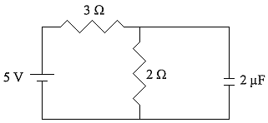

(A) 2 V, 410-6 C

(B) 2 V, 10-5 C

(C) 5 V, 410-6 C

(D) 5 V, 10-5 C

(E) 4 V, 510-6 C

23. An alternating voltage, oscillating at 60 Hz, takes on a maximum value of 170 V during each cycle. If an rms (root mean square) voltmeter was hooked up to this circuit, what would the reading be?

(A) 120 V

(B) 140 V

(C) 170 V

(D) 240 V

(E) 220 V

24. The 4 kg mass is pulled to the right by the unknown mass *M*, over a tabletop having a coefficient of friction of 0.25 with the 4 kg mass. The pulley is frictionless. If both masses in the preceding question are doubled, what is the new acceleration?

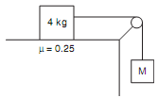

(A) 2 m/s2

(B) 4 m/s2

(C) 6 m/s2

(D) 8 m/s2

(E) 10 m/s2

25. An object moves along the *x*-axis with a changing acceleration described as *a* = 7*t*, where *a* is in m/s2 and *t* is in sec. At *t* = 0, its velocity and position are both zero. When *t* = 2 seconds, it is located closest to

(A) 1 m

(B) 3 m

(C) 5 m

(D) 7 m

(E) 9 m

26. The ammeter reading is closest to

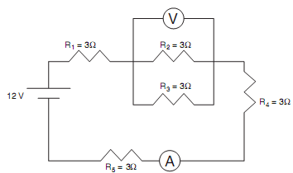

(A) 1 A

(B) 2 A

(C) 3 A

(D) 4 A

(E) 5 A

27. The voltmeter connected across the 3 Ω resistor indicates a potential drop of

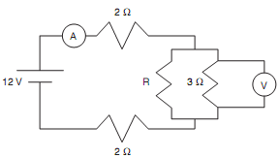

(A) $\frac{1}{5}$ V

(B) $\frac{1}{3}$ V

(C) V

(D) V

(E) V

28. The equivalent capacitance of this circuit is nearest to

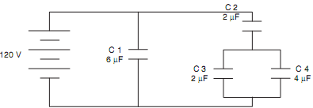

(A) $\frac{5}{6}$ µF

(B) $\frac{6}{5}$ µF

(C) 7 µF

(D) 7.5 µF

(E) 10.5 µF

29. A wire of length 0.2 m moves through a constant magnetic field at a 90° angle and velocity of 0.2 m/s as shown. The 0.5 T magnetic field is directed into the paper. The emf induced in the wire is most nearly

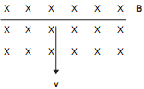

(A) 0.02 V

(B) 0.2 V

(C) 2 V

(D) 10 V

(E) 20 V

30. A charged 5 µF capacitor measures a potential difference of 120 V. The potential energy stored in the capacitor is

(A) 3.6×10–4 J

(B) 3.6×10–3 J

(C) 3.6×10–2 J

(D) 3.6×10–1 J

(E) 3.6 J